Projectile Motion

Name: ____________________________
If you throw a ball straight up, its velocity decreases due to a constant downward acceleration (g = -9.8 m/s² assuming upward direction to be positive and negligible air resistance), its velocity becomes zero at the maximum height and then its velocity becomes negative (since it moves downward) and keeps increasing in the negative direction until it reaches ground. The velocity and acceleration graphs as a function of time are shown below.
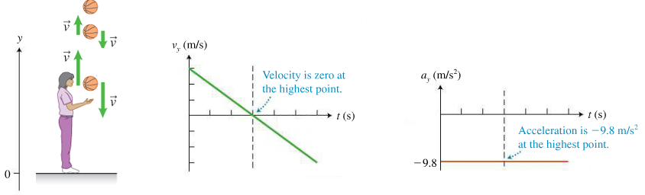
The equations of motion for an object moving along a straight line (one dimensional motion) with constant acceleration in this case would be:
$$v_{f}=v_{i}+at$$
$$y_{f}=y_{i}+v_{i}t+\frac{1}{2}at^{2}$$
$$v_{f}^{2}-v_{i}^{2}=2a\left(y_{f}-y_{i}\right)$$
If you throw the ball at an angle ball, it exhibits projectile motion.
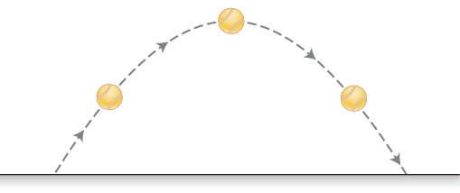
Since the ball moves both horizontally (along x-axis) and vertically (along y-axis), we will need 6 equations motion, 3 for the horizontal motion and 3 for the vertical motion. The velocity will have x and y components, similarly acceleration will also have x and y components.
For motion along x-axis:
$$v_{fx}=v_{ix}+a_{x}t$$
$$x_{f}=x_{i}+v_{ix}t+\frac{1}{2}a_{x}t^{2}$$
$$v_{fx}^{2}-v_{ix}^{2}=2a_{x}\left(x_{f}-x\right)$$
And for motion along y-axis:
$$v_{fy}=v_{iy}+a_{y}t$$
$$y_{f}=y_{i}+v_{iy}t+\frac{1}{2}a_{y}t^{2}$$
$$v_{fy}^{2}-v_{iy}^{2}=2a_{y}\left(y_{f}-y_{i}\right)$$
We will try to perform a few experimental activities, in order to understand the projectile motion using these equatios.
Open the simulation:
https://phet.colorado.edu/sims/html/projectile-motion/latest/projectile-motion_en.html
Double click on the “Vectors” box.
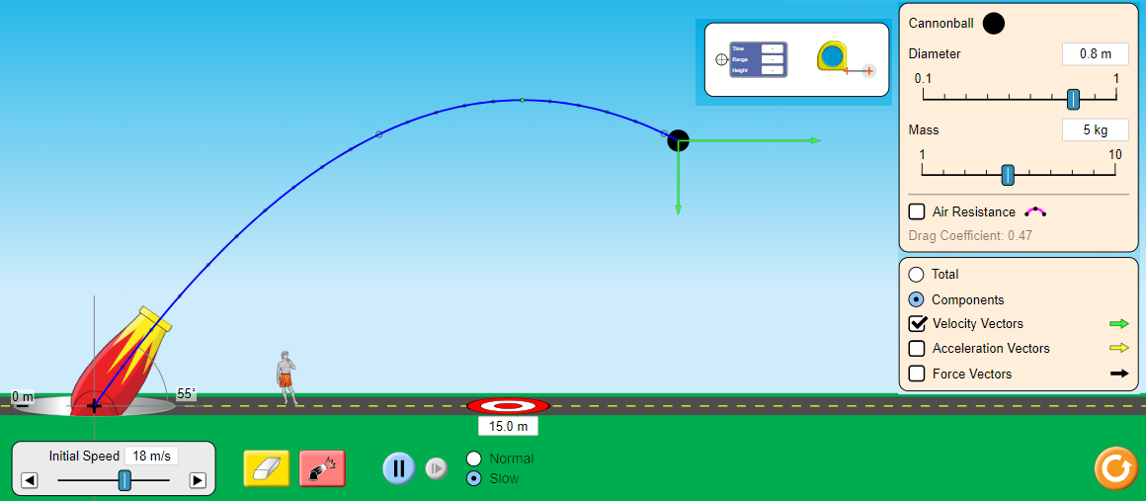
Familiarize yourself with the simulation. Play around with the settings, shoot the cannon ball with different initial velocities and at different angles, with and without the air resistance. When you are finished testing all the settings, click on the orange reset button.
Step 1: Adjust the cannon at an angle of 60º relative to the ground. Click on “Slow” tab to track the motion slowly. Uncheck the “Air Resistance” box to perform an experiment without the air resistance. Check both the “Components” and the “Velocity Vectors” tabs.
Step 2: Shoot the cannon ball and observe how the x and y components of the velocity change during the motion. You can shoot it a few times, to make sure that you can observe both components carefully.
How does the x-component of the velocity change during the projectile motion?
Your answer: Does not change
How does the y-component of the velocity change during the projectile motion?
Your answer: It decreases as the ball rises and increases as the ball falls
Step 3: Uncheck the “Velocity Vectors” box, and check the “Acceleration Vectors” box. Shoot the ball again.
What the direction of the total acceleration of the box?
Your answer: Downward direction
How does the acceleration change during the projectile motion?
Your answer: Acceleration remain constant
Step 4: Uncheck the “Acceleration Vectors” box and check the “Force Vectors” box. Shoot the ball again.
What the direction of the total force on the ball?
Your answer: Downward direction
How does the force on the ball during the projectile motion?
Your answer: Force does not change
Are your answers to questions in steps 2, 3 and 4 consistent with each other? Explain.
They are not all constant. This is so because X velocity does not change while Y velocity changes
Step 5: Uncheck the “Force Vectors”, and check the “Acceleration Vectors” box. Also check the “Air Resistance” box to turn on the air resistance. Shoot the ball and notice how acceleration arrow is pointing down to the left. If it is not obvious, increase the speed to maximum and shoot the ball again, you will see it. Without the air resistance, the acceleration was pointing straight down? Why does the air resistance make it tilt to the left? Explain in terms of forces.
The acceleration tilts to the left because of reduction in resultant force acting on the ball due to introduction of air resistance force.

Step 6: From steps 2 and 3, it should be obvious to you that the horizontal component of the velocity stays constant but the vertical component of the velocity behaves exactly like that of a ball thrown straight up, that we discussed earlier (in negligible air resistance). This is because of the fact that the only force that is causing downward acceleration is gravity, and there is no force in the horizontal direction, hence there is no horizontal acceleration and thus the horizontal component of velocity stays constant. So the equations of motion for projectile motion from page will become:
For motion along x-axis:
$$v_{fx}=v_{ix}$$
$$x_{f}=x_{i}+v_{ix}t$$
$$v_{fx}^{2}-v_{ix}^{2}=0$$
And for motion along y-axis:
$$v_{fy}=v_{iy}+a_{y}t$$
$$y_{f}=y_{i}+v_{iy}t+\frac{1}{2}a_{y}t^{2}$$
$$v_{fy}^{2}-v_{iy}^{2}=2a_{y}\left(y_{f}-y_{i}\right)$$
The first and the third equation for motion along x-axis mean the same thing, i.e. x-component of the velocity stays constant. So, in fact we have only one equation of motion along x-axis and 3 equations for motion along y-axis. They are:
$x_{f}-x_{i}=v_{ix}t$ (1)
$$v_{fy}=v_{iy}+a_{y}t (2)$$
$y_{f}=y_{i}+v_{iy}t+\frac{1}{2}a_{y}t^{2}$ (3)
$$v_{fy}^{2}-v_{iy}^{2}=2a_{y}\left(y_{f}-y_{i}\right) (4)$$
Where: a_{y} = - 9.8 m/s².
Step 7: Let’s see how these equations work.
Assume that a projectile is shot horizontally at 20 m/s from a height of 10 m. That means:
Initial height: y_{i} = 10 m
Initial speed: v_{i} = 20 m/s
Initial angle: θ = 0º
Calculate the x and y components of the initial velocity.
v_{ix} = v_{i} cosθ = 20 Cos 0 = 20m/s
v_{iy} = v_{i} sinθ = 20 Sin 0= 0m/s
Step 8: Find the time the projectile takes to hit the ground using equation (3). Remember that: y_{i} = 10 m, y_{f} = 0 m (since it hits the ground at the end), a_{y} = - 9.8 m/s², and you know v_{iy} from step 7. Find time t. Show all your work below.
$$y_{f}=y_{i}+v_{iy}t+\frac{1}{2}a_{y}t^{2}$$
-10=1/2*-9.8*t²
-10= -4.9t²
t²=2.040816
t= 1.42857
$t=$1.43sec
Step 9: Now use substitute this time t into equation (1) to find out how far the ball hits the ground (horizontally), from the point of launch. Show all your work below.
$$x_{f}-x_{i}=v_{ix}t$$
20*1.43=28.6m
$x_{f}-x_{i}=$ 28.6m
Step 10: Let’s test these predictions experimentally. Click on the “Intro” tab at the bottom of the simulation. This will open the part of the simulation where the cannon is placed on a tower 10 m above the ground. From the drop-down menu on the top right-hand corner, select “Cannonball”. Adjust the initial speed to 20 m/s. Drag the target mat to the right until it is exactly at the distance that you calculated in step 9 above. Then, shoot the ball.
Did the ball hit the target?
Your answer: Yes
Step 11: Drag the “Time,Range.Height” meter and place its crosshair exactly at the location where the ball hit the ground. The meter should display a height of 0 m.

Take a screenshot of your simulation along with the meter and paste it in the space below.

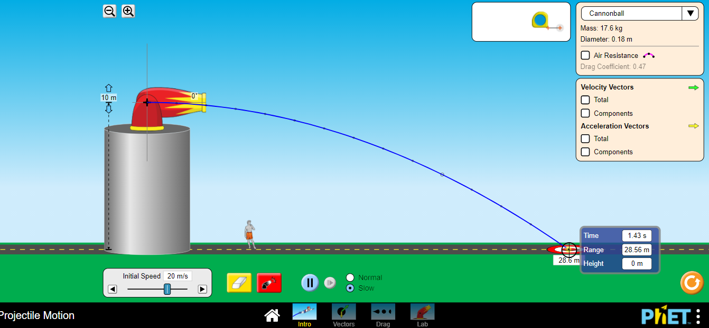

What is the time reading on the meter?
Your answer: 1.43sec
Does your time reading on the meter match with your prediction in step 8?
Your answer: Yes
What is the range reading on the meter (this is how far the ball lands from the point of launch)?
Your answer: 28.56m
Does your range reading match with your prediction in step 9?
Your answer: Yes, only a slight difference brought about by rouding off.
Step 12: If a projectile is launched from the ground with a speed of 18 m/s at an angle of 60º.
- Calculate the time it spends in the air? Show all your work below.
t= 2V_{i} Sin θ/g
2*18Sin 60/9.8
=3.1813
=3.18sec

- How far does it land from the point of launch? Show all your work below.
Range= {18²*sin (2*60)}/9.8
28.63m

